Citizen AI: Intelligent Citizen

Engagement Platform

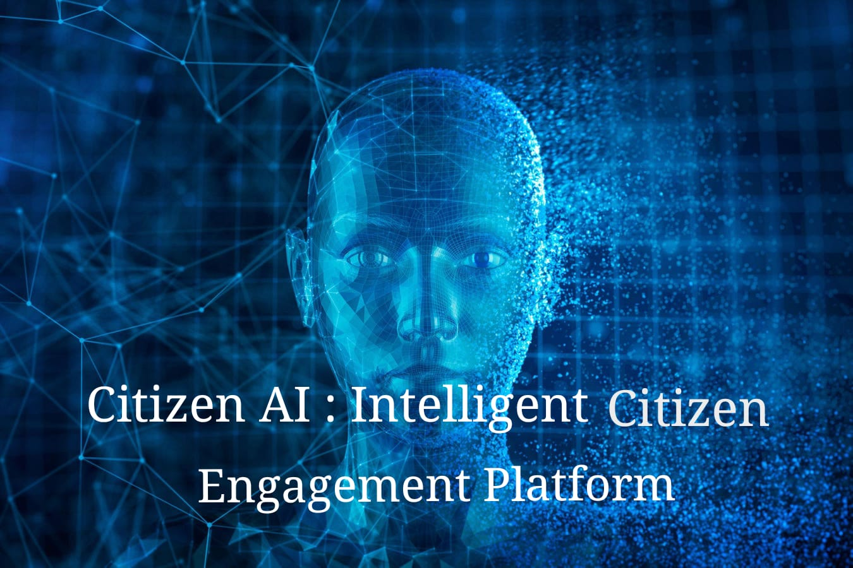

Team Members

* Yogasree.B
* Nivetha.R
* Shahaniya.S
* Senthamizhselvi.T

# Introduction

Citizen AI is an intelligent citizen engagement platform designed to provide quick, helpful answers about government services and civic issues. By leveraging IBM Granite models from Hugging Face, the project uses generative AI to assist citizens while also tracking public sentiment. The system presents results via a simple dashboard for government officials, ensuring transparency and better decisionmaking.

# Project Overview

Objective: Improve citizen–government interactions using AI.

Core Features:

AI-powered chatbot for answering civic/government service queries.

Sentiment analysis for understanding public feedback.

Dashboards for officials to visualize trends.

Deployment: Built and executed on Google Colab with lightweight Granite models for low-cost, GPU-backed performance.

Tech Stack:

Python (core programming)

Transformers & Torch (model execution)

Gradio (UI for chatbot)

IBM Granite Models (Hugging Face)

GitHub (version control & hosting code)

# Architecture

High-Level Flow:

1. Frontend (Gradio UI) – User interacts via chatbot interface.
2. Model (Granite-3.2-2b-instruct) – Processes queries and generates responses.
3. Sentiment Analysis Layer – Tracks public mood and feedback.
4. Backend (Colab Runtime) – Executes Python code, loads AI models, and manages API calls.
5. Dashboard (Optional) – Displays analytics for government officials.
6. Version Control – Source code maintained on GitHub.

# Setup Instructions

Prerequisites

Basic knowledge of Python, Gradio, Git.

IBM Granite Models access (Hugging Face account).

Google Colab (with T4 GPU).

Steps

1. Google Colab Setup

Open Google Colab

Create a new notebook and rename it to Citizen AI.

Go to Runtime → Change runtime type → Select T4 GPU.

Install dependencies:

!pip install transformers torch gradio -q

1. Model Selection

Create a Hugging Face account.

Choose granite-3.2-2b-instruct model.

1. Run Application

Execute provided Python script.

Launch Gradio app → interact via generated URL.

1. GitHub Deployment

Create repo → upload .py code → commit changes.

# Authentication

Hugging Face: Requires user account for accessing IBM Granite models.

Google Colab: Login with Google account to run GPU-backed notebooks.

GitHub: Authentication for project hosting and collaboration.

(Optional: If using IBM Watsonx API, API key authentication may be required.)

# User Interface

Gradio-based Chatbot:

Input box for user queries.

Output area for AI responses.

Dashboard (Future Scope):

Visualizes sentiment analysis results.

Provides actionable insights for officials.

# Testing

Functional Testing

Verify chatbot response quality.

Test sentiment analysis accuracy.

Performance Testing

Evaluate model response speed on Colab GPU.

Integration Testing

Ensure Gradio UI works seamlessly with Granite model.

User Testing

Collect feedback from sample users.

# Known Issues

Limited GPU session time on Google Colab (12-hour cap).

Requires stable internet connection.

Dependency on Hugging Face model availability.

Currently lacks advanced error handling.

Dashboard not fully integrated in this version.

# Future Enhancements

Add multi-language support for inclusivity.

Develop mobile-friendly interface.

Enable offline deployment (via Docker or local hosting).

Expand dashboard with advanced data visualizations.

Integrate Watsonx API for enterprise-grade scalability.

Improve authentication and access control for secure usage.

# 10.Project Screenshort

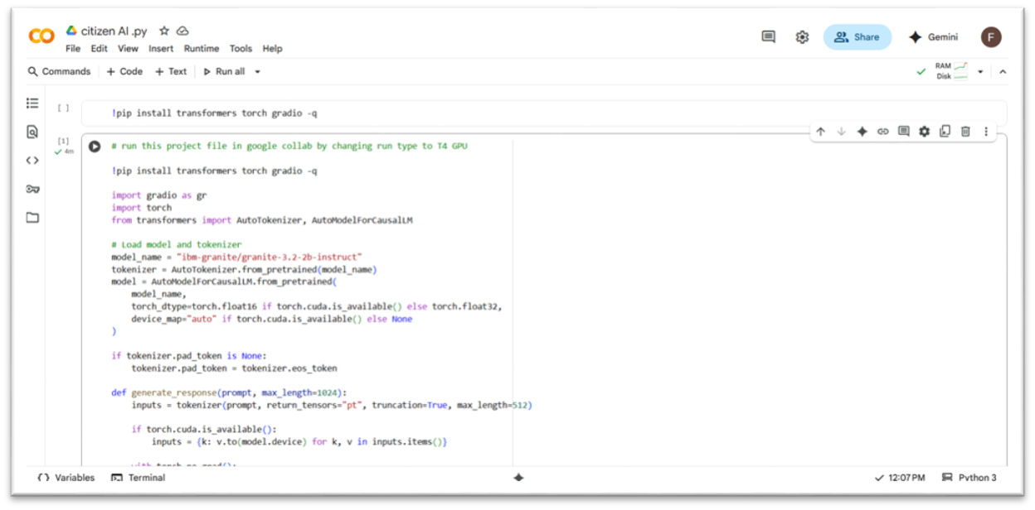

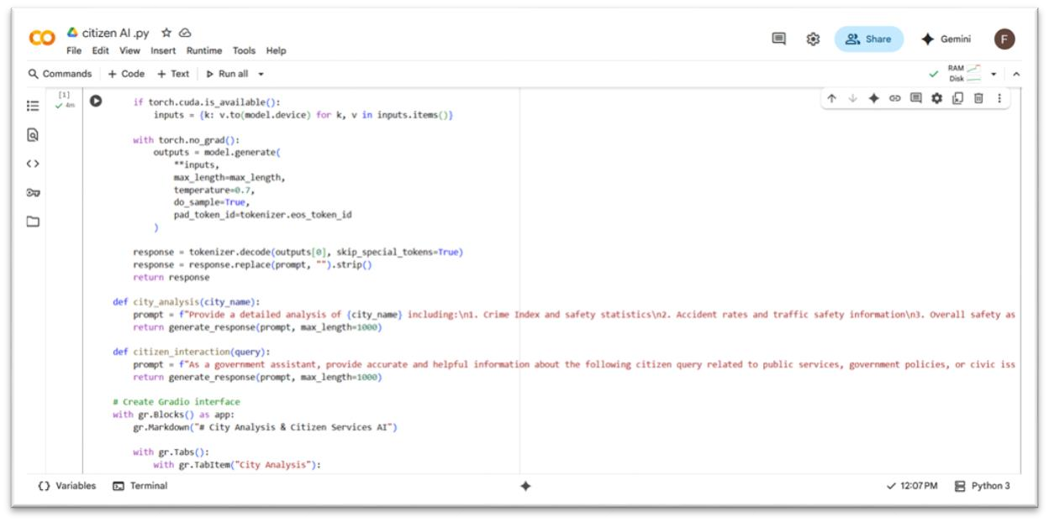

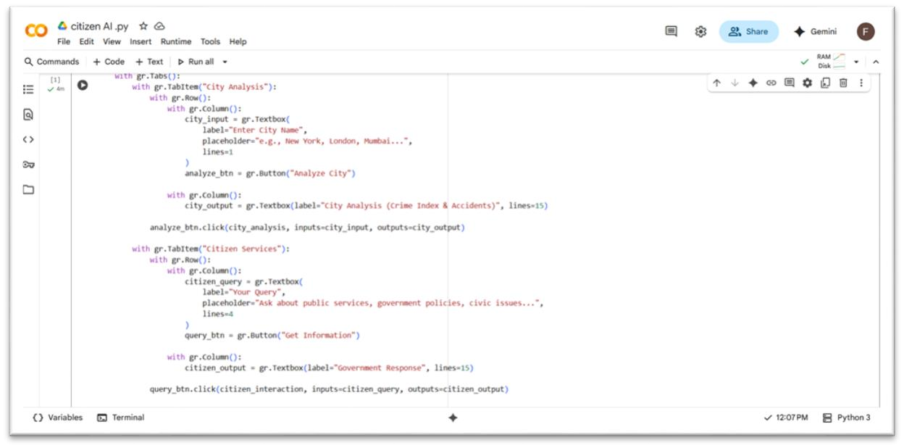

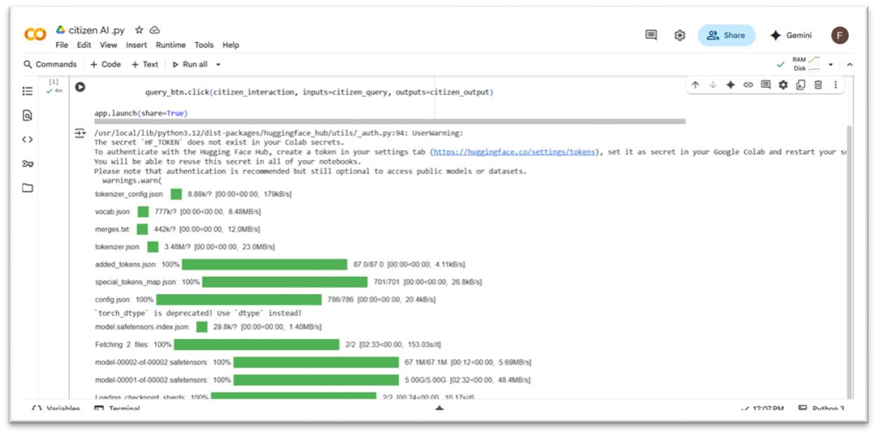

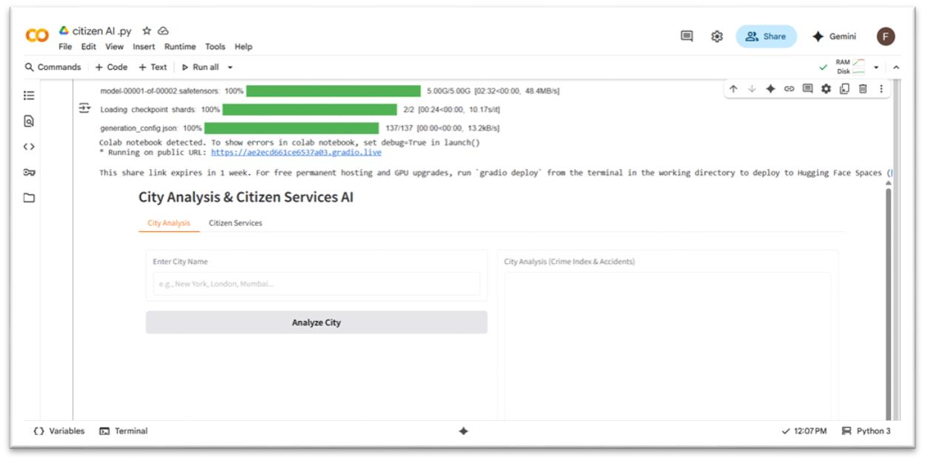

# 11.Conclusion

The Citizen AI: Intelligent Citizen Engagement Platform project was successfully done by H.Femeena ,R.Harini , Harini.R , R.Kavipriya.

# 12.Demo video link

[**https://drive.google.com/file/d/1ljjrF7LLVlMT8_TWl0HYGwLYCFA2s TeB/view?usp=sharing**](https://drive.google.com/file/d/1ljjrF7LLVlMT8_TWl0HYGwLYCFA2sTeB/view?usp=sharing)